**“FUNDAMENTALS OF PROGRAMMING”**

**“LAB ASSIGNMENT: 01”**

**SUMITTED TO: SIR MUHAMMAD AFFAN**

**SUBMITTED BY: MOMINA HAQ (468932)**

**ME-15 (B)**

**TASK 01:** **Write a C++ program to display factors of a number using for loops.**

**CODE:**

#include <iostream>

using namespace std;

int main(){

int x;

cout << "Enter a number: ";

cin>>x;

cout<<"The factors of the given number are : " ;

for (int i = 1; i <= x; i++) {

if (x%i==0) {

cout<<i<<endl;

}

}

return 0;

}

**OUTPUT:**

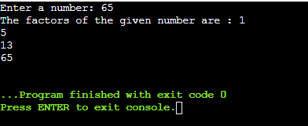

**TASK 02:** **Write output to the following code.**

**CODE:**

#include int main()

{ int x = 5; int y = 10; if (x == 5) if (y == 10)

std::cout << "x is 5 and y is 10" << std::endl;

else std::cout << "x is not 5" << std::endl;

return 0; }

**OUTPUT:**

**x is 5 and y is 10**

**TASK 03:** **Write a C++ program, take an integer value from user and check if it’s greater than 10 and less than equal to 20. Print 1 if yes and print 0 if no. Use appropriate datatype for output.**

**CODE:**

#include <iostream>

using namespace std;

int main() {

int x;

cout<<"Enter a number: ";

cin>>x;

if (x > 10 && x <=20) {

cout<<"1";

}

else {

cout<<"0";

}

return 0;

}

**OUTPUT:**

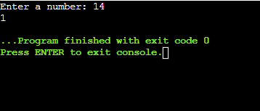

**TASK 04: Write a C++ program that uses a while loop to find the largest prime number less than a given positive integer N. Your program should take the value of N as input from the user and then find the largest prime number less than or equal to N. You are not allowed to use any library or pre-existing functions to check for prime numbers.**

**CODE:**

#include <iostream>

using namespace std;

int main()

{

int num, x,y,fact ;

cout<<"Enter a number: ";

cin>>num;

x = num;

while (x >= 2) {

fact = 0;

y = 1;

while (y <= x) {

if (x%y==0) {

fact++; }

y++;

}

if (fact==2) {

cout<<"The highest prime number less than the given number is: "<<x;

break;

}

x--;

}

return 0;

}

**OUTPUT:**

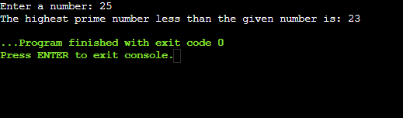

**TASK 05:** **Write a C++ program, take two string as input from user and check if both strings are equal or not. If they are equal make them unequal by rotating string. e.g., Hello is turned into olleH etc.**

**CODE:**

#include <iostream>

#include <string>

using namespace std;

int main()

{

string stg1,stg2,rotate;

rotate="";

cout<<"Enter the first string:";

cin>>stg1;

cout<<"Enter the second string:";

cin>>stg2;

if (stg1 == stg2){

for (int x=0;x<stg1.length();x++){

rotate=stg1[x]+rotate;

}

cout<<"Strings are unequal. Rotated string is : ";

cout<<rotate;

}

else {

cout<<"Strings are unequal";

}

return 0;

}

**OUTPUT:**

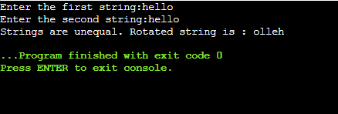

**TASK 06:** **Perform division in C++ without / using for loops. You can use / only to display the final results. Your dividend must be greater than divisor.**

**CODE:**

#include <iostream>

using namespace std;

int main()

{

int dvd, dvs, rem, quo;

cout<<"Enter the value of divisor: ";

cin>>dvs;

cout<<"Enter the value of dividend: ";

cin>>dvd;

rem = dvd;

for (int i = 1; i <= dvd; i++) {

rem -= dvs;

if (rem < dvs) {

quo = i;

break;

}

}

cout<<dvd<<" / "<<dvs<<" = "<<quo;

return 0;

}

**OUTPUT:**

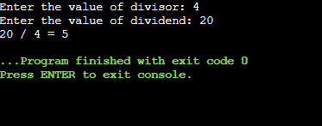

**TASK 07:** **Write a C++program for a string which may contain lowercase and uppercase characters. The task is to remove all duplicate characters from the string and find the resultant string.**

**CODE:**

#include <iostream>

#include <string>

using namespace std;

int main()

{

string string, ans;

bool letter;

cout<<"Enter a String: ";

cin>>string;

ans = "";

for (int i = 0; i < string.length(); i++) {

letter = false;

for (int j = 0; j < ans.length(); j++) {

if ( string[i] == ans[j] ) {

letter = true;

}

}

if (letter == false) {

ans += string[i];

}

}

cout<<"Changed String: "<<ans;

return 0;

}

**OUTPUT:**

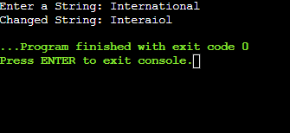

**TASK 08:** **Suppose an integer array a[5] = {1,2,3,4,5}. Add more elements to it and display them in C++**

**CODE:**

#include <iostream>

using namespace std;

int main()

{

int array[5] = {1,2,3,4,5},newArray[10];

cout<<"Previously existing array: {";

for (int i = 0; i<5; i++) {

cout<<array[i];

if (i==4)

continue;

cout<<", ";

}

cout<<"}"<<endl;

for (int i = 0; i<5; i++) {

newArray[i] = array[i];

}

cout<<"Enter 5 digits to add to previously existing array: "<<endl;

for (int i = 5; i<10; i++)

cin>>newArray[i];

cout<<"New array will be : "<<endl;

for (int i = 0; i<10; i++) {

cout<<newArray[i]<<" ";

}

return 0;

}

**OUTPUT:**

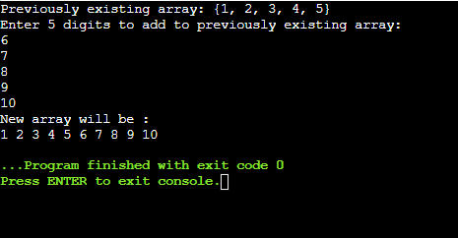

**TASK 09:** **Given an integer array and an integer X. Find if there’s a triplet in the array which sums up to the given integer X.**

**CODE:**

#include <iostream>

using namespace std;

int main()

{

int array[5], X, ans , x, y, z;

bool result = false;

cout<<"Enter a value of integer X: ";

cin>>X;

cout<<"Enter integers for array: "<<endl;

for (int x = 0; x<5; x++) {

cin>>array[x];

}

cout<<"Triplets that sum up to the given number are = ";

for ( x = 0; x<5; x++) {

for ( y = 0; y<5; y++) {

if (x == y)

continue;

for ( z = 0; z<5; z++) {

if (z == x || z == y)

continue;

ans = array[x] + array[y] + array[z];

if (ans == X) {

cout<<" ("<<array[x]<<", "<<array[y]<<", "<<array[z]<<")";

result = true; }

}

}}

if (result == false) {

cout<<" 0";

}

return 0;

}

**OUTPUT:**

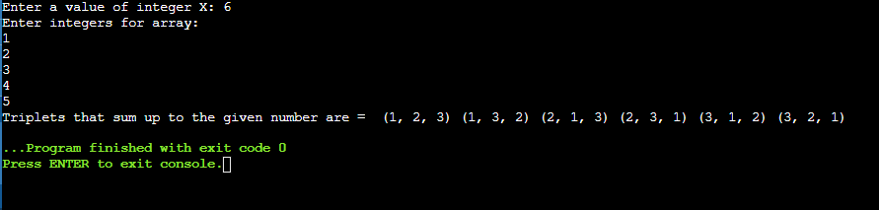

**TASK 10: Implement Bubble Sort on an array of 6 integers.**

**CODE:**

#include <iostream>

using namespace std;

int main() {

#define size 6

int array[size], x,y,a;

for(x=0;x<size;x++)

{

cout<<"Enter the values of array: "<<endl;

cin>>array[x]; }

for(x = 0; x < size-1; x++) {

for(y = 0; y < size-1-x; y++) {

if(array[y] > array[y+1]) {

a = array[y];

array[y] = array[y+1];

array[y+1] = a;}

} }

cout<<"After sorting , the array becomes :"<<endl;

for(x = 0; x < size; x++) {

cout << array[x] << " ";

}

return 0;

}

**OUTPUT:**

